**Student Questions**

Learn about the internals of a standard PC case by examining physical samples and selecting and labeling images found on-line. Gain deeper knowledge by researching and reporting on specific components.

PC Tower Case

1. Find one (or more) images that clearly show the internals of a PC Tower Case.   
   (i.e. Google images using keywords “PC Case Internals”)
2. Clearly label the following components (using arrows) on your image of the PC case internals:
   1. Motherboard
   2. Power Supply
   3. Hard Disk Drive
   4. Optical Disk Drive (e.g.DVD)
   5. USB Expansion Ports
   6. Monitor Port
   7. Audio Ports
   8. Ethernet Port
   9. Cooling Fan

*Ports are not shown well

1. Research more in-depth about “Hard Disk Drives”. Make notes on the following:
   1. What different versions are currently available (speed and capacity)

* Solid State Drives (SSD)
* Hard Disk Drive (HDD)
* The average PC has a hard drive with speeds around 7200 RPM
  + Low-end PCs have speeds around 5900 to 5400 RPM
* Capacity of hard drives can range from 250 GB to even multiple terabytes depending on what the user plans on doing with their PC
  1. How the capacity of the component has changed since the 1980’s
* In the 1980s, the hard drives had a capacity of 2.5 gigabytes
* Now, that would be nothing and we have more capacity in small devices like our smart phones
* This shows a very vast progression of hard drives from the 1980s to today’s day and age

PC Motherboard

1. Find one (or more) images that clearly show the layout of a PC Motherboard.   
   (i.e. Google images using keywords “PC Motherboard”)
2. Clearly label the following components (using arrows) on your image of the PC motherboard:
   1. CPU (and fan)
   2. RAM Memory
   3. Disk Drive Interface (IDE or SATA)
   4. GPU Graphics Processor (either on-board or Graphics Card) (On board)
   5. Sound Processor (either on-board or Sound Card) (on board)
   6. Wi-Fi / Ethernet Network Interface (either on-board or Graphics Card) (on board)

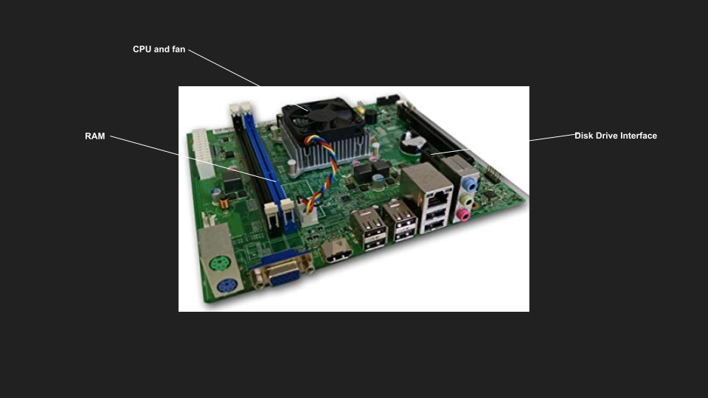

1. Research more in-depth about “CPU Processor Chip”. Make notes on the following:
2. What different versions are currently available (speed and capacity)

* The two main companies today who are making these chips are Intel and AMD along with others but are very rare
* Intel’s CPUs which are used on average are the I3, I5, I7, and I9 but the I7 and I9 are very powerful and are mostly for the high-end users all having very high speeds and capacities
* AMD is the second-best supplier and their Ryzen series competes to Intel’s I series
  + These CPUs are the Ryzen 3, 5, and 7
  + Ryzen however have CPUs which many uses for their gaming PCs as they are cheaper and equal or even superior to the I series

1. How the speed of the component has changed since the 1980’s

* CPUs from the 1980s would not have good performance as todays day and age by a long shot
* These cores would not be able to handle much of anything we would do today on laptops
* They would be able to complete minor tasks but not some of the average tasks today
  + Ex. Today’s video games

Peripheral Devices

1. Find one (or more) images that clearly show the layout of the back of a typical PC tower case.   
   (i.e. Google images using keywords “Back Of PC Tower”)
2. Clearly label the following components (using arrows) on your image of the back of a typical PC tower case:
   1. Power cord and power switch
   2. Monitor Interface (VGA or DVI or HDMI)
   3. Mouse Interface (USB or PS/2)
   4. Keyboard Interface (USB or PS/2)
   5. USB Ports
   6. Audio Inputs / Outputs
   7. Ethernet Interface

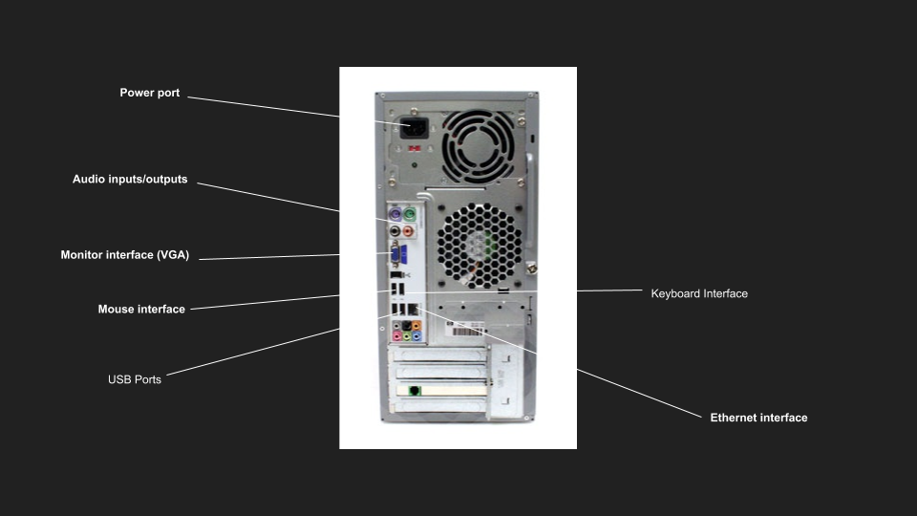

1. Research more in-depth about “External Portable Storage”. Make notes on the following:
2. Floppy Disks

* A form of storage
* Comes in multiple sizes
* Used to store memory and data
* Not used much anymore due to CD and USB

1. CD-ROM / DVD / Recordable CD/DVD

* A form of storage
* Also contains memory and data
* Can be in different sizes and different memory capabilities
* Still used but is starting to become obsolete due to hard drives and online downloads and cloud

1. USB Memory Drives

* A form of storage
* Contains files, memory, and data
* Comes in multiple storage capabilities
* Still used very much today in schools and the workplace

1. Compact Flash Memory

* A form of storage in the shape of a card
* Can come in multiple sizes and memory capabilities
* Can be used on multiple types of devices from phones to laptops
* Still used a lot in today’s day and age, especially in cameras and smartphones with micro-SD card slots

1. Cloud Based Storage

* A form of storage developed in the recent years
* It is all online and network based
* Is much more convenient for those who do not want to have no memory left on their devices
* Can be inconvenient if you are not connected to Wi-Fi, ethernet, or cellular data
* Examples are Google drive, iCloud, etc.

**Presentation Outline**

Explore the development and features of a specific PC hardware component through deeper research and investigation. Work in partners to create a short presentation. Deliver the presentation to the class.

Each group will research a unique PC hardware component. Your specific topic will be assigned from the list provided below.

**Presentation Structure**

1. Explain what the PC component does and how it fits together with other components to make up a fully functioning PC.
2. Explain how the PC component works. Provide a diagram (image) showing the main parts of the component.
3. Research the current state of the art of the component in terms speed, capacity (size), and other related factors.
4. Research on-line suppliers that sell the PC Component. List the specifications for the available products and the cost (price).
5. Research how the PC component has changed and evolved since the early days of PCs in the 1980’s. Cover each of the following topics separately:
   1. Component Speed
   2. Component Size / Capacity
   3. Two other specifications specific to the PC component (ask Mr. Nestor)

**PC Component Topics**

|  |  |  |
| --- | --- | --- |
| **Topic** | **Partner 1** | **Partner 2** |
| CPU Microprocessor Chip |  |  |
| Motherboard Layout |  |  |
| Computer Graphics |  |  |
| Sound & Audio |  |  |
| Hard Disk Drives |  |  |
| Removable Disk Storage |  |  |
| Ethernet / Fiber Connectivity |  |  |
| Wifi / Bluetooth Connectivity |  |  |
| Mouse / Pointing Devices |  |  |
| Monitor & Display Technology |  |  |
| Printers & Output Technology |  |  |